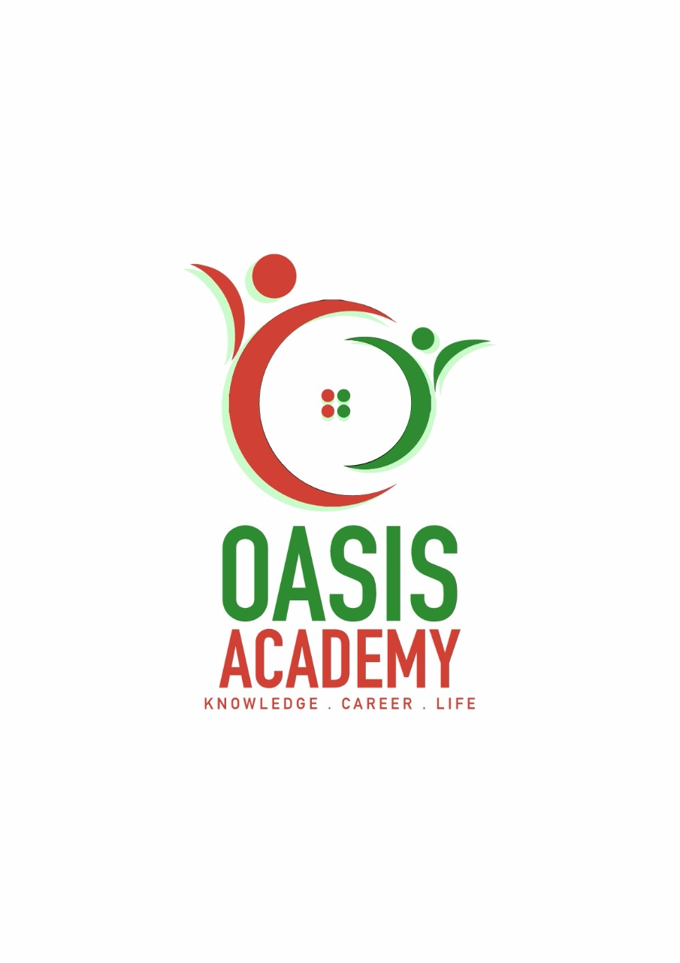

Name: NG KAE XUAN

Login ID: ngkaexuan@oasis-portal.com

Course Title: Essentials of Human Resource Management

Subject Code: BHM 01

Submitted date: 5/6/2017

**Table of Contents**

|  |  |  |
| --- | --- | --- |
| No | Details | Page |
| 1 | Executive Summary | 3 |
| 2 | Introduction | 4 |
| 3 | Assignment Question | 5 |
|  | Part 1 | 5-6 |
|  | Part 2 | 7-8 |
|  | Part 3 | 9-10 |
|  | Part 4 | 11-12 |
| 4 | Conclusion | 13 |
| 5 | References | 14-16 |
|  | Appendix | 17 |

**Executive Summary**

In this assignment, we can see what we studied in this module. Human Resources Management is a tool to have a communication with the employee and how to work in the company. In the Human Resources Management including knowledge, necessary tools, training, administrative services, coaching, legal and management advice, and talent management oversight. In first of the assignment, I’ll define the major activities and human resources operation in hospitality management. Secondly, I’ll explain the planning trend and what my understanding of action plan human resources planning in the hotel industry. After that in the third part of the assignment, I covered the topic and going to describe and brief about function and policies in Human Resources and how does the policy apply accordingly in Hospitality Management. Lastly, I’ll explain in detail of organizational behavior and brief on groups and structure in the organization in Hospitality Industry.

**Introduction**

Human resources management refers to the management of the process involved in the management of personnel or personnel tasks. Human resources management includes job analysis, development of human needs planning and recruitment, training and development, pay and benefits management, performance appraisal, labour relations management.

Human resources management is more and more attention. In the mature system of economic development, human resource management should work together to achieve the best benefits, if there is no suitable staff, the location is not ideal, resource utilization efficiency is not only, or may have been exhausted. Modern economists emphasize balance and cooperation to improve management efficiency and quality, it is necessary to balance human resources, the framework of the content is to provide human resources framework, with the most suitable people to do the most suitable work. The establishment of human resources platform, with the communication and information collection channels, the parties sweeping, short-term need a long time to deal with remuneration, benefits, and other matters. Human resources are the most important training and development of enterprises, human resources development, should invest in training, play the human resources potential of the various departments.

Human resources management and development is the current business problems. We should understand that the victory of international competition is the development of human resources and management of the victory. A country's economic development, and its human resources development and management of the success of a great relationship, and now the pursuit of development, we must first attach importance to human resources management, in the era of knowledge economy, people are to create knowledge, dissemination of knowledge, the main application of knowledge, He is the most important factor in the elements of productivity, therefore, efficient human resource management has become the main force of knowledge economy development.

**Assignment Questions**

**Examples:**

Assignment question in this part contain 4 questions

**Question 1**

Define the major Activities and Human Resource Operation in Hospitality Management.

Human resource management is an indispensable function in an organization. Simply to manage the organization of human resources to enable organizations to have a better development, the use of talent and proper management to the organization to a higher level. They are responsible for organizing the recruitment, mediation, and incentive of human resources and the processes and activities of all management plans for future development plans. The definition of human resource development can be defined in two ways. In the employee's perspective, it is a system that can improve the development of workers, it can enhance personal work knowledge, skills, change the work attitude and ideas to improve work efficiency. Therefore, the organization engaged in human resources in the activities at the same time, we must also understand the views of employees for the organization. In addition, in the organizational perspective of human resource management, it is based on the organization of the organization and the plan in the operation of a sector, its purpose is through a variety of training and development activities, so that employees get the job required knowledge and skills, ideas and Attitude, in line with the organization now and the future arrangements for the plan, to achieve the goal set.

The following will list some of the activities that are important in human resource management。

Recruiting

In the recruitment of human resources, planning the organization of human resources, to understand the current lack of talent and talent to join the post arrangement. Proper job analysis can be properly recruited and selected. The primary factor in the existence of human resources is to find the right people to exist at the right time in the right place to complete the work that needs to be done.

Selecting

Candidates must be recruited based on recruitment, looking for suitable people to arrange in the appropriate positions, design to work with the standard selection of the standard press, while the use of work standard selection program to improve the efficiency of the photo. First, we must first establish a perfect job standard requirements and job evaluation to conduct management. Second, the use of modern technology to facilitate the selection, such as network interviews, document examinations and so on. This will be able to improve and complete the standard.

Training

Training is a training related to the current work, and it has many specific objectives in a relatively short term. Usually based on the way the group and pay attention to some specific methods. Training is more than employees in the work of the considerations but cares about the immediate effect.

Motivation

The incentive is the organization through the establishment of the way should be reward and work, with certain normative and punitive measures, with information communication to stimulate and guide or maintain and naturalize the behavior of employees to achieve the organization set the future goals.

Compensation

Salary management is to say that an organization's work attitude towards employees is identified as the reward and reward that they deserve. To motivate employees to work more on the work, the organization will continue to develop a new salary plan to determine the staff salaries and constantly communicate with the staff and run.

Human resources management Hotel management is divided into several categories, the first is the reception and reception services, they usually belong to the reception and provide good service for the guests. Followed by hotel services, belonging to the room service category, for example, call the hotel room service to order and the like. In the next step is the hotel's F & B department, guests will be prepared for a variety of breakfast lunches or dinners, most of which will be accompanied by ordering the hotel with the gift. The last is the security department, which is also a very important department, the guests will only choose to let them feel at ease of the hotel, a variety of surveillance systems and security in hospitality management played a significant role.

**Question 2**

Describe in brief on Human Resources Planning and Planning Trend in hospitality.

Explain what is your understanding on Action Plan Human Resources Planning in Hotel Industry.

Describe in brief on Human Resources Planning and Planning Trend in hospitality.

Enterprises in the strategic planning and development direction, according to internal and external changes, set the enterprise in the future development and demand for human resources. Human resource planning is based on the organization's development direction and objectives in a systematic way to allocate the organization's human resources needed. So that the organization's human resources and demand to achieve a balance.

The purpose of human resource planning is to set up better to the goal and the use of the organization's human resources to complete the goals set. The first is the planning of human development, followed by the rational use of human resources to promote the same time with the needs of organizational development, and finally, reduce the cost of employment to improve the company's capital flows.

Trends of planning in Human Resources Management:

Customer 's hotel planning and booking plan, to understand the customer's favorite hotel planning and proper publicity

Online Reviews For customers to choose the importance of the hotel, customers will usually make a lot of searches which also include a review of the hotel's comments to find out the actual situation of the hotel.

What content is important to the customer, what is important for the customer depends on how you stand in the customer's point of view to select the hotel, which includes the price considerations, preferential package, perfect equipment, and traffic Convenience and other.

Social media in the customer hotel booking decision-making process of influence, and now the technology is also developed a great nowadays can be a wide range of publicity more in a wide range of publicity. For example, you can use the application can also use the page publicity and the like, which can be more economical to achieve excessive publicity effect.

Mobile use of mobile applications, which is another modern way of propaganda, it can be advertised in the mobile phone application or use the phone to search for more relevant hotel information, you can also easily use the phone online booking hotel.

Explain what is your understanding on Action Plan Human Resources Planning in Hotel Industry

The first is strategic planning, to determine the impact of organizational goals on specific organizational units, to ensure that all traditional HR programs can meet the needs of senior staff and job managers to maintain the stability of the work. Again, it is a human resource management plan that defines the skills needed to meet the goals and the need for professional knowledge to meet human resources. Recognize the organization's strategy involves and affects the level of human resources. Followed by a comparison of needs and available gaps, assessment of available talent and resource forecasts, and human resource demand forecasts. Consider the existing human resources to determine the net demand and identify those who may affect the business objectives of human resources. And then the distribution of human resources, for example, if the human surplus will choose to stop using, pay cuts, early retirement or dismissal. If there is a shortage of manpower, it will choose to publish the recruitment according to the standards of human resources management to carry out screening for the talents that are suitable for the organization, or if there is no need for any action if the supply is balanced. The last is to develop a plan of action to achieve the expected human resource needs, to review the strategic planning process and to identify new opportunities for human resources personnel to participate.

**Question 3**

Brief about Human Resources functions and Human Resources Policies.

Describe the functions of management and how the policy applies accordingly in hospitality management.

Question 3: Brief about Human Resources functions and Human Resources Policies.

The definition of human resource management functions is to systematically manage the human resources in the organization, while properly managing the organization's staff more into and into the organization's future. First, the organization through the recruitment and screening of the appropriate people to the appropriate job placement and should be new employees to enter the organization and provide training so that employees can make them more quickly into the work environment, to achieve new employees and leaders can quickly run to improve the efficiency of each new employee. Occasionally set up a write event and party to achieve creative cooperation, the establishment of a harmonious working relationship, and timely to resolve the contradictions between employees. The Department of Human Resources Management also needs to develop the following corporate policies and working methods to make it easier to meet the organization's current policies and future, as well as assess the performance of the staff and reward and control labour costs. After the assessment of the staff will be organized to selectively develop the staff's work skills to improve work efficiency. The last is to protect the health of employees and try to improve the material and working environment.

The human resource policy is the policy provision for the acquisition and development of human resources to achieve the goals set forth and then maintained and used.

There are five actions:

Hierarchical, when the development of policies at the same time need to consider the middle and lower staff differences such as managers and employees need to implement the policy is also different.

Classification, which is in the development of policies at the same time need to consider the different departments of employees, such as production, sales, management, there will be different policies.

So that the policy is to take into account the need to encourage employees to move toward higher positions but to encourage employees to be down-to-earth in their posts, making us manage the simplification of the home.

In a phased manner, it means that the human resource management is different in the absence of time. As the changing organization needs to follow the style of the times, human resource management can change from time to time.

Humanization, humanization is also very important in the policy is also the most special, because it and other policies are the difference between human nature, but need to pay attention to is not let the policy of humanized deterioration into a human.

Describe the functions of management and how the policy applies accordingly in hospitality management.

In the hotel in accordance with the principle of a reasonable system, according to the needs of enterprises to achieve the goal, from the maximum to mobilize the enthusiasm of the work, creativity, to develop a package, including selection, training, use, assessment and rewards, including labour and personnel system and distribution System, scientific and post-set, so that the best combination of things and things.

Human resources department is characterized by both the stage goal, but also must carry on the end, never-ending pursuit. Because of the development of society, the progress of science and technology will continue to put forward new tasks for human resources development, and the hotel management thinking, management system, management tools and management methods of scientific, modernization itself also requires employees to constantly adjust their knowledge structure, the Own level of knowledge. Human resources department as much as possible for the performance of their ability to provide opportunities for their employees to obtain the knowledge in practice into the experience rose to theory.

The following policies and functions:

1. Comprehensive. The hotel's human resources management not only includes the functions of providing personnel services such as the provision of talent and other personnel according to the overall goal of the hotel, but also how to create a good working environment, mobilize the enthusiasm of the staff, guide the staff work and improve the staff's work Environment and living conditions, the development of the potential of the staff and so on.

2. Fullness. The hotel should regard every employee as a valuable resource, have long and short-term human resources development and development planning, to achieve their own work and improve the quality of the purpose.

3. Dynamic. Managers should not only according to the overall goal of the hotel to select the right people, the hotel staff recruitment, training, rewards and punishments, promotion, and retirement the whole process of management, but also pay attention to the dynamic management of staff work process, that is, Understand the staff's emotional changes and ideological trends, and take appropriate measures to mobilize the enthusiasm of the staff, so that all staff to fully play the potential of the ability.

4. Systematic. Hotel Human Resource Management is a system engineering, composed of several subsystems running around the total system goal by hiring system, training system, use system, reward and punishment system, retreat system and so on.

5. scientific. Hotel human resource management is not only a complex, comprehensive system engineering, it should be scientific management, and gradually realize the standardization, procedures, institutionalization and quantitative

**Question 4**

Explain in detail about organizational behavior in hospitality and brief on group and structure in the organization.

Explain in detail about organizational behavior in hospitality and brief on group and structure in the organization.

Organizational behaviour is a science in the study of human behaviour and psychology in the organization. It is a branch of behavioural science. With the development of society, especially the development of the economy has promoted the development of enterprise organization, organizational behaviour has been paid more and more attention. Organizational behaviour also has many of its own branches, such as corporate organizational behaviour, school organizational behaviour, organizational behaviour, organizational behaviour, and so on. At present, the research of organizational behaviour is more and more widely applied. Therefore, it is common to treat organizational behaviour and organizational behaviour. Organizational behavior is an edge discipline, which is based on behavior, and psychology, sociology, anthropology, engineering, computer science and other disciplines intersect.

Organizational behavior is the new development of management psychology, they are both consistent and there are some differences.

Which includes the individual in the organization, his individual behaviour as the basis and work attitude and job satisfaction. But also includes personality and values ​​as well as individual decision-making. The last is the motive, which includes the concept of motivation, mood, and state of mind, emphasizing the motivation to the concept. The next is the group of organizations, which is based on group behavior. The first thing is to understand the work team and establish good communication, but also have the basic view of leadership. The last is the organizational system, which is the basis of organizational structure but also the culture of the organization, which focuses on human resources policies and practices.

From the development of organizational behaviour, organizational behaviour be a new development of management psychology. Organizational behaviour and management psychology are consistent in terms of the purpose, object, content and theoretical source of the study. Specifically, in:

(1) The purpose of the study is the same. That is, through the organization of human psychology and behaviour of the study, to reveal its laws, and to guide the behaviour of individuals, groups or organizations to achieve the organization's expected goals.

(2) the object of the study is consistent. Organizational behaviour and management psychology regard behaviour and psychology as their research object. When the behavioural behaviour of a certain organization in the organization of human behaviour and its rules can’t be involved in human psychology, when the management of psychological research management process of human psychological characteristics and their laws can’t be involved in human behaviour.

(3) the content of the study is much the same. Organizational behaviour and management psychology are basically the same content framework, such as including individual problems, group problems, incentives, leadership issues, organizational culture and change issues.

(4) Many theoretical sources are the same. Although the theoretical sources of organizational behaviour are broad, many theoretical sources are the same as the theoretical sources of management psychology, such as psychology, sociology, anthropology, pedagogy, and physiology. Which is a major subject of psychology.

The difference between organizational behaviour and management psychology

Although organizational behaviour and management psychology in many ways are the same or consistent, are marginal disciplines and applied disciplines, many scholars are also easy to mix the two together, but they still have some differences. Table 1-2 compares these differences. According to the author's view, the main difference between organizational behaviour and management psychology is that the object of study is the external, observable and variable behaviour of the organization, and the latter is the organization (Including external, observable, variable behaviour, including inner, even unobservable, immutable behaviour, such as thinking, instinct). Which determines the organizational behaviour of the research results more specific, intuitive and practical, and management of psychological research results are more abstract, obscure and theoretical.

The next step is the organizational principles of hotel management, which include the organization of the ability and organizational form to obey the objectives of the organization, the distinction between classes and high-level command principles. Followed by the principle of organizational width and empowerment, the organizational principles of the organization, and finally the principle of solidarity.

But the hotel management and management of the main points. The first is the hotel's organizational structure, the division of the hotel sector mainly based on business content and business needs, while achieving the purpose of efficient streamlining. The second point is the type of organizational structure of the hotel, it can be classified as four structures, is the straight line organizational structure, linear functional organization, organizational structure and matrix organizational structure. There are many types of hotel organizational structure, but how organizations choose organizational structures depend on which aspects of the organization develop and organize their needs.

It is to explore the main content of the organization and management of the hotel, to determine the structure of the organization after the construction of the entity, and then determine the specific content of the hotel organization and management. The first is the distribution and running of the business, the management of the staff and appropriate to adapt to determine the task is assigned after the distribution system and partial system to determine the staff, and finally the labor organization. But before all this you need to have a sense of the hotel system, each type of system on the hotel management and operation plays a certain normative role. They complement each other, complement each other to form the hotel system.

Finally, the implementation of the system is also very important point. The organization required for the implementation of all systems guarantees the education of law and institutions and creates excellent organizational culture and then carries out rigorous and equitable assessment and rewards to maximize the goals of the organization. Organizational system of the implementation of the subjective conditions for the staff of the basic quality and quality of staff to shape.

**Conclusion**

In general, the development of human resources more emphasis on personal development, from the internal cooperation with the external development of the individual. And human resource management more concerned about the needs of the organization, with the use of manpower. Furthermore, it is organized to recruit the right talent to arrange the desired location to achieve a simpler shortcut to achieve the goal. There is a good affirmation and reward system, for the organization to bring high-quality progress. For example, the staff to pay a reasonable return to this also contributed to their efforts to complete the work. Timely incentives for employees to make it more sophisticated for the work, play a better performance. Employees in the work of the performance will directly affect the production and development of enterprises, so most of the enterprise will be a very important part of human resources management and assets. The use of human resources is also an indispensable part of the need to meet their ability to achieve the goal set the key to the important.

**References**

Wikipedia.(2017).(online).Human Resources Management.retrived from <https://en.wikipedia.org/wiki/Human_resource_management>

HRMP.(2017).(online).Activities of HRM.retrived from <http://hrmpractice.com/activities-of-hrm/>

Investopedia, LLC.(2017).(online).Human Resources Planning -HRP.retrived from http://www.investopedia.com/terms/h/human-resource-planning.asp

Smriti Chand.(2016).(online). Human Resource Management: Meaning, Objectives, Scope and Functions.retrived from <http://www.yourarticlelibrary.com/hrm/human-resource-management-meaning-objectives-scope-and-functions/35229/>

Susan M. Heathfield.(2017).(online). Sample Human Resources Policies and Procedures.retrived from <https://www.thebalance.com/sample-human-resources-policies-and-procedures-1918876>

Wikipedia.(2017).(online). Human resource policies.retrived from <https://en.wikipedia.org/wiki/Human_resource_policies>

Ruth Mayhew.(2017).(online). Six Main Functions of a Human Resource Department.retrived from <http://smallbusiness.chron.com/six-main-functions-human-resource-department-60693.html>

Smriti Chand.(2016).(online). Steps in Human Resource Planning (explained with diagram).retrived from <http://www.yourarticlelibrary.com/human-resources/steps-in-human-resource-planning-explained-with-diagram/32358/>

HRMP.(2017).(online). LINKING ORGANIZATIONAL STRATEGY TO HUMAN RESOURCE PLANNING.retrived from <http://hrmpractice.com/linking-organizational-strategy-human-resource-planning/>

MSG.(2017).(online). Environmental Scanning - Internal & External Analysis of Environment.retrived from <http://www.managementstudyguide.com/environmental-scanning.htm>

Zeinul Haleem.(2014).(online). Human Resource Management in Hotel Industry.retrived from <https://www.slideshare.net/ZeinulHaleem2/human-resource-management-in-hotel-industry>

Guest61a8d3.(2007).(online). Human Resource Planning In Hotel Business.retrived from <https://www.slideshare.net/guest61a8d3/human-resource-planning-in-hotel-business>

Ahmed Ghazi Mahafzah.(2016).(online). Department of Tourism and Hospitality Management.retrived from <https://www.omicsgroup.org/journals/the-role-played-by-strategic-planning-in-the-performance-of-hotel-hrdepartments-the-case-of-turkish-republic-of-north-cyprus-trnc-2167-0269-1000243.php?aid=79985&view=mobile>

Rutaihwa Aristides Andrew.(2016).(online). 14 Current Trends in Human Resource Management.retrived from <https://www.linkedin.com/pulse/15-current-trends-human-resource-management-rutaihwa-aristides-andrew>

Sujai.(2010).(online). Formulating HR Plans.retrived from <http://sujai-human.blogspot.my/2010/11/formulating-hr-plans.html>

Ciel s cantoria • edited by: Marlene Gundlach.(2015).(online). Human Resources Strategic Planning and a Sample HR Action Plan.retrived from <http://www.brighthubpm.com/resource-management/26611-human-resources-strategic-planning-and-a-sample-hr-action-plan/>

Farook_A_Azam.(2009).(online). Human Resource Planning.retrived from <https://www.slideshare.net/Farook_A_Azam/ahrm>

Gemma Costa.(2009).(online). Management In The Hospitality Industry.retrived from <https://www.slideshare.net/gemcosta/management-in-the-hospitality-industry?qid=408bfee0-c03b-4223-af47-be153607bced&v=&b=&from_search=8>

Hardeep Kumar.(2009).(online). Organizational Behavior 638 Slides Presentation.retrived from <https://www.slideshare.net/taquilla/organizational-behavior-638-slides-presentation?qid=941e0e39-ae93-46dc-b8b1-cafc2c4bcb82&v=&b=&from_search=1>

Priyasharmma.(2011).(online). Organizational behavior.retrived from <https://www.slideshare.net/priyasharmma/organizational-behavior-6858461?qid=bb69ace0-c630-405b-876d-60071aea73f2&v=&b=&from_search=2>

Crystial Parrilla.(2015).(online). Hospitality Organizational Management: Introduction.retrived from <https://www.slideshare.net/CrystialParrilla/hospitality-organizational-management-introduction?qid=4940ee66-da9b-442d-9f06-24915613d663&v=&b=&from_search=1>

Feng Scott.(2017).(online). HUMAN RESOURCE MANAGEMENT FOR THE HOSPITALITY AND TOURISM INDUSTRIES.retrived from http://www.academia.edu/8042224/HUMAN_RESOURCE_MANAGEMENT_FOR_THE_HOSPITALITY_AND_TOURISM_INDUSTRIES

Rodrigo.(2012).(online). Human Resource Management in the Hospitality Industry.retrived from <https://writepass.com/journal/2012/11/human-resource-management/>

Carmen Domínguez-Falcón.(2014).(online). Human resources management and performance in the hotel industry: The role of the commitment and satisfaction of managers versus supervisors.retrived from <http://www.emeraldinsight.com/doi/abs/10.1108/IJCHM-08-2014-0386?journalCode=ijchm>

**Appendix**

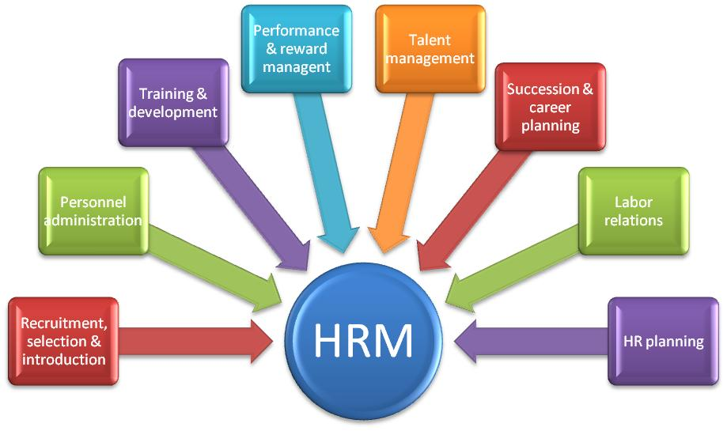

Figure 1 : HR Management .Adapted from Keith Kerr.(2017)

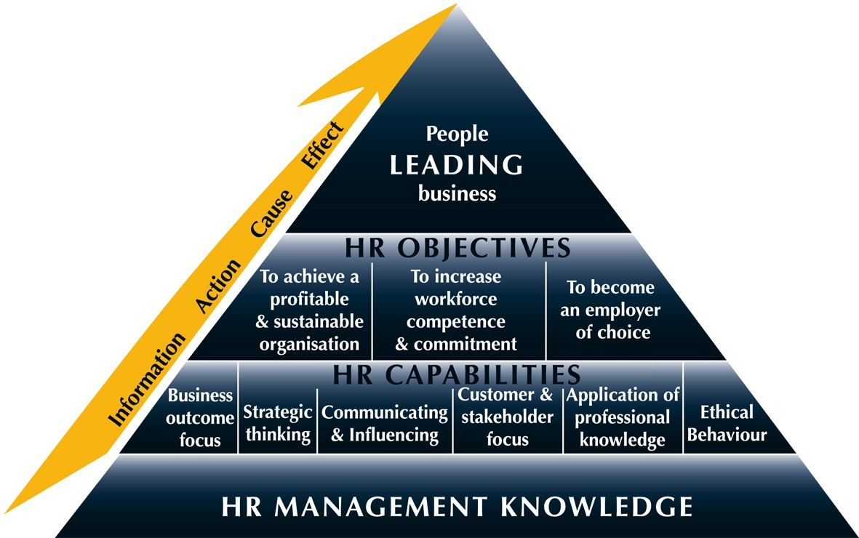

Figure 2 : Human Resources Management Knowledge .Adapted from AssignmentDesign.com.(2017)